
No. Pendaftaran 829 (Selangor)

Issue No. 08/05 - August 2005

2005

MEMBERS’ CIRCULAR
MONTHLY CALENDAR OF EVENTS
English | Tamil | Day | Event
August  2005 | Aadi
1 | 16 | Monday | Dwadasi
2 | 17 | Tuesday | Pradosham
3 | 18 | Wednesday | 18th Day of Aadi
4 | 19 | Thursday | Aadi Ammavasai, Tharpanam
8 | 23 | Monday | Aadi Pooram
9 | 24 | Tuesday | Chathurthi vrutham
11 | 26 | Thursday | Shashti vrutham
16 | 31 | Tuesday | Ekadasi vrutham
 | Aavani
17 | 1 | Wednesday | Dwadasi, Prodosham
19 | 3 | Friday | Pournami  RIG AND YAJUR VEDA UPAKARMAM  POURNAMI POOJA (7.00 p.m. to 9.00 p.m.)  SRI VARA LAKSHMI VRUTHAM
20 | 4 | Saturday | GAYATHRI JAPAM
22 | 6 | Monday | Sankatahara Chathurthi
26 | 10 | Friday | Karthigai vrutham  SRI KRISHNA JAYANTHI
27 | 11 | Saturday | BHAJANA (7.00 p.m. to 9.00 p.m.)
30 | 14 | Tuesday | Ekadasi vrutham
31 | 15 | Wednesday | Dwadasi
Sept 2005
1 | 16 | Thursday | Pradosham
3 | 18 | Saturday | Ammavasai Tharpanam
6 | 21 | Tuesday | SAAMA VEDA UPAKARMAM
7 | 22 | Wednesday | Chathurthi vrutham; VINAYAGAR CHATHURTHI
8 | 23 | Thursday | RISHI PANCHAMI
9 | 24 | Friday | Sashti vrutham
14 | 29 | Wednesday | Ekadasi vrutham
15 | 30 | Thursday | Dwadasi, Pradoshm  THIRU ONAM

PRESIDENT’S MESSAGE

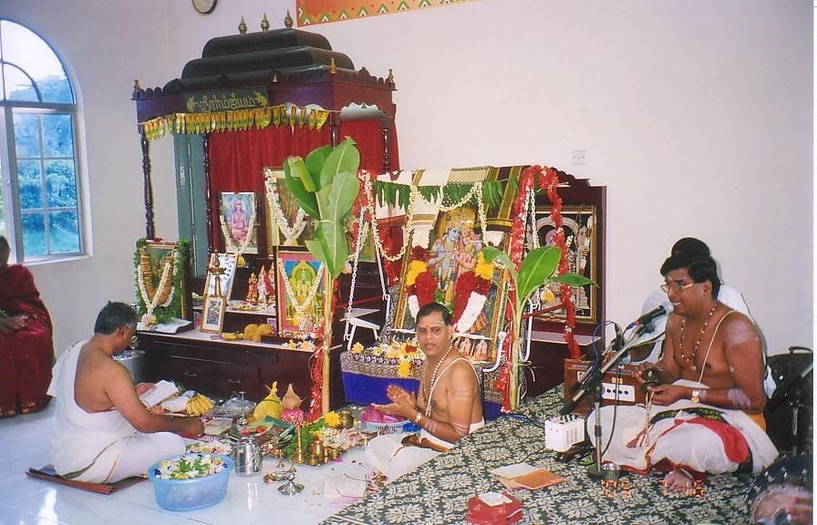

Udayalur Sri Kalyanarama Bhagavathar and group presented the traditional bhajana with all the 24 ashtapathis and conducted the Radha Kalyana Mahotsavam in our samajam hall on 16th and 17th July. All those present had a rare treat to participate in this function amidst the ambience of the hall and the samajam deities. The rendering of the naamasangkeerthans were melodious and his explanations meaningful.

The bhagavathar praised our conduct of monthly traditional bhajanas and confirmed that our Sri Rama Navami procedures were correct and in order.

The Committee plans to tile the outside floor at the riverside. We have an estimate from a contractor for the works as RM 11,500/-. The Committee hopes to raise this funds by contribution from members who have not yet contributed to the building fund. Please contact the Committee if you want to make any contribution to this.

HON. SECRETARY’S EDITORIAL
We were indeed blessed to have been able to witness the 2-day Sri Radha Kalyana Mahotsavam conducted by Sri Udayalur Kalyanarama Bhagavathar & Group for the first time in our Samajam. We hope we would be able to make this mahotsavam yet another annual function in future.

As per Baltasar Graham, “Great ability develops and reveals itself increasingly with every new assignment” .

THE MONTH TO BE

Rig And Yajur Veda Upakarmam
- Friday, 19th August 2005 ( Aavani 3)
The Yajur Upakarnam which falls on Friday, 19th August 2005 will be conducted at the Samajam in two sessions from 7.00 a.m. to 8.00 a.m. and 9.30 a.m. to 11.30 a.m. (with Homam). All those who would like to participate in the first session please contact the Priest, Sri Sankaranarayana Sharma Shastrigal H/p: 017 6368002.
Poonals for outstation members are enclosed.
Pournami Pooja
- Friday, 19th August 2005 ( Aavani 3)
The Pournami Pooja for August will be held on Friday, 19th August 2005.
Any member who wants to sponsor the pooja can contact the Hon. Secretary or the President.
Members, families and friends are invited to take part in this Pooja.

Samooha Bhajana
- Saturday, 27th August 2005 (Aavani 11 )
The August Samooha Bhajana will be held on Saturday, 27th August 2005. The Bhajana will be sponsored by members from Brickfields/ Taman Seputeh

On behalf of the sponsors, we invite all members, their families and friends to participate in the Bhajana.

EDUCATION FUND BOARD
The Fund announces 2 new awards namely Somasundram Merit Award (for Youth Achievement/Arts) and Madam Saraswathy Merit Award (for Performing Arts).Details and application procedure will be announced in the next circular.

SRI VALAMPURI VINAYAGAR TEMPLE
Members are requested to contact the following persons with regard to the services of the priest: V. Subramanian, Hon. Secretary, Temple Association (03-22825099); N. Srinivasan, Hon. Treasurer, Temple Association (03-79569507);
The daily temple poojas are being conducted by the priest. Members are encouraged to subscribe to daily poojas that are payable monthly at the rate of RM30 only. The monthly sankatahara chathurthi and chathurthi homam and abhiseghams have started. Members can bring prasadams for the occasion or any other pooja items including fruits, garlands or flowers. Members are requested to sponsor the events for RM 50 and additional RM15 for the Sahasranamam. Sanghabishegam can be sponsored for RM250 for which prasadham will be prepared by the temple as nayvidyam.
The priest is prepared to teach members on reciting of the sahasranamam for various deities and pooja procedures. Members need to pay for these classes. The rates have to be discussed with the priest.
MEMBERS’ COLUMN - NEW MEMBERS / CHANGE OF ADDRESSES & CONTACT NUMBERS
Members’ Change in Address / Tel. Numbers

M’ship No. | Name | Change in Address and/or Contact No.
161 | Parasuraman E | Tel No. : 03-6095 0502  H/P No: 019-386 0028

MEMBERS' NOTICES

Award

Mrs. Padma Venkatesh (361) received the “Kalanyar Award” for her contribution to music and drama during the Kannadasan ilakkya Vizha held on 2nd July, 2005 at Kuala Lumpur.

Our congratulations to Mrs. Padma Venkatesh.

Death

1. Mr A.N.Ananthakrishnan (167) passed away peacefully on 25th June 2005 in Singapore, leaving behind wife Parvathy , daughter Lakshmy(Gowri), son-in- law Bhaskar Narayanan(L-313) & grandson Iresh.

2. Mrs K.N.S. Aiyer nee K. Lalitha Nagaraj (L-127) passed away peacefully on 5th July 2005, leaving behind her sons Mohanram Kumar (L-30) &Gopinath (L-55), daughters Shyamala, son-in-law, daughters-in-law, grandsons, granddaughters, relatives and close friends.

The family wishes to thank members of the Samajam, relatives and friends for their presence, condolences, prayers, assistance and support given in the hour of their distress.

3. Mrs. Lakshmi w/o the Late T. Krishna Moorthy Iyer (Kuantan) passed away peacefully on 6th July 2005 (Wednesday), leaving behind son K.Ravikulothman, (368) wife Mangalam (Santha) (Kuantan); Daughters/Sons-In-Law, Urimala/G. Mohan(L-19); Srimathy / Ashok S. Padmanabhan (230); Sumathy / A. Subramaniam and Santhi/Ramesh,K. (483). Grandchildren : Sri Ram Ashok, Jaya Ram Ashok and Priyanka A. Subramaniam and their families.

The family members wish to thank the members of Brahmana Samajam, relatives & friends for their kind presence, condolences, assistance, help & support during their recent bereavement.

4. Shri R. Subramaniam ( 120) , formerly of IMR, passed away peacefully on the morning of the 7th of July 2005 leaving behind beloved wife Padma, daughter Lakshimi ,son Raman, daughter -in-law Swarupini, and grandchildren Gayathri, Gowri and Vidhya.

The family would like to take this opportunity to thank the Management Committee and all the members of the Brahmana Samajam for their presence, condolences , invaluable assistance , support and kindness during their recent bereavement.

5. Mrs Vasantha Thothathri Nath passed away peacefully on 10th July 2005 leaving behind husband
Mr. R Thothathri Nath (042), sons Ganesh, Suresh & daughter Uma.

Our condolences to the bereaved family members

The following page contains two obituaries written by members.

Acknowledgment
“I would like to thank all those members of our community who rendered physical help and emotional support to my daughters and me during my husband’s stay at University Hospital and who helped to make all the necessary arrangements for his funeral.

We are very grateful to all those who also helped us to ensure all preparations for the 9th - 13th day ceremonies went on smoothly.
Thank you all very much for your help and support. May God Bless Us All”. Shanta Krishnamoorthy.

President
Ir. Dr. K.S. Kannan
20 Jalan Terasek Enam, Bangsar Baru, 59100 K.L
Tel: (Hse) (603) - 2284 9784 / (H/p) 013-3363814
E-mail: kskutm@pd.jaring.my

Hon. Secretary
Ms Malini Badri Narayanan
No. 7, Jalan 14/60, 46100 Petaling Jaya, Selangor
Tel: H/p–012 2990883;
E-mail: malinibn@hotmail.com

Hon. Treasurer
Mr. N. Raman
No. 16,Jalan Hujan Batu Satu, Taman Overseas Union, 58200 KL
Tel : (603) 7981 5293
E-mail : nraman@pd.jaring.com

Priest
Sri Sankaranarayana Sharma Shastrigal
H/p: 017 6368002

Malini Badri Narayanan, Hon Secretary
25th July 2005

Insurance Joke. (sent by Mr.Ashok Padmanabhan)
A lawyer and an Engineer were fishing in the Caribbean.
The lawyer said, "I'm here because my house burned down and everything I owned was destroyed by the fire. The Insurance Company paid for everything."
That's quite a coincidence," said the engineer, "I'm here because my house and all my belongings were destroyed by a flood, and my Insurance Company also paid for everything."
The lawyer looked somewhat confused. "How do you start a flood?" he asked.

OBITUARY

MRS LALITHA NAGARAJ – A LADY OF QUALITY

On Wednesday 5th July 2005 we lost yet another elderly and prominent member of our small community. She succumbed to complications arising from an operation to remove a constriction in her colon about a week before that at the University Hospital, Petaling Jaya.

Though a frail person of advanced age at the time of her passing, she was nonetheless a great personality in her own right.

She was the wife of the late KNS Aiyer, a former President of the Samajam and the one time Chief Executive Officer of Life Insurance Co-operation of India which later evolved into AMAL and UOA. This alone would have put her on the map as she was already mingling with the top echelon of KL society long before anyone else in the community ascended to that position by virtue of her husband’s office. Yet there is more to say of her. She mothered four children – 3 boys and a girl; their distinguishing hallmark was brilliance. Unfortunately on occasion this distinction tipped them over to the other side so that rationality was not always the norm! She was a well read person with no airs about her. She never interfered in the affairs of others but always was a source of affection and inspiration if turned to for assistance. Her knowledge of the ancient language of Sanskrit and of our scriptures was phenomenal. It is a great pity that her vast talents in these areas were not exploited by the Samajam for the benefit of our members and more particularly our youth.

The family has lost a great matriarch and the whole community a lady of quality. As we must all go one day, being the only certainty in life – let us wish her soul everlasting peace. It now remains for all of us and more particularly her children, grand children and in-laws to model their life’s on the example she set; that is to live life with “malice towards none and charity to all”.

Member

OM SHANTI ! SHANTI ! SHANTI !

Demise of a great mother

Mrs Vasantha Thothathri Nath was born in 1942 at Tanjore, India. She came to Malaysia after her marriage in 1963. She brought up all three of us siblings with lots of love and care. Besides her other domestic talents, her culinary skills were enjoyed by all--near and far--and my friends loved to partake of her North Indian dishes. She was actively involved in the Samajam, Sai Baba Group and volunteered her culinary skills at Devi Annapoorna.

She was a cheerful person and did her best to bring us up with traditional values. She worked tirelessly for her family and her community; her only worries centred on the welfare of her children.

She succumbed to complications of accidental burns. She passed away peacefully on 10th July 2005. We are proud of her and will forever uphold and embody the values she stood for. Please join us in prayers, as we ask the Almighty to help her
soul rest in peace.

Ganesh, Suresh, Uma

